INFAMOUS AERO CO.
Ford Focus RS – V2 Front Splitter Chassis Mount Install

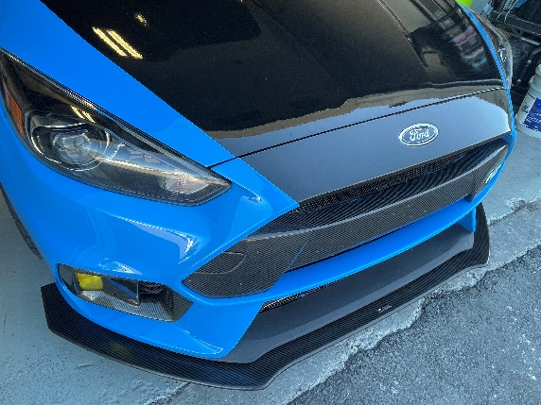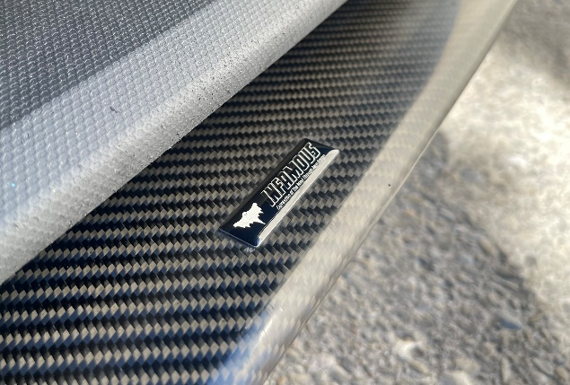
Kit Includes:
Infamous Aero V2 Splitter, Infamous Aero Chassis Mount Center Bracket, Infamous Aero Chassis Mount Side Bracket (x2), Infamous Aero Decals (x2), Infamous Aero Gel Badge, M8x30 Bolts (x8), M8 Fender Washers (x16), and M8 Locking Nuts (x8).
Necessary Tools:
Panel Clip Remover (Flat Head Screwdriver), 13mm Wrench, 10mm Wrench, ¼” Rachet, ½” Rachet, 13mm Socket, 10mm Socket, Torques bit, Drill, and Drill Bits.
Step 1: Remove Front Bumper & Headlights
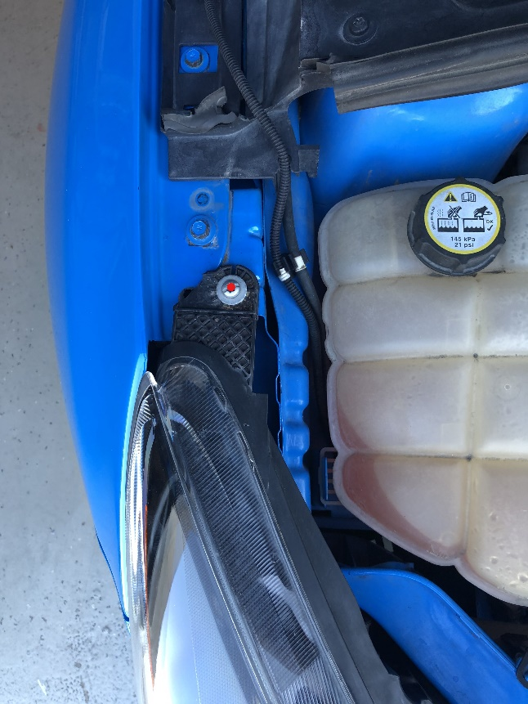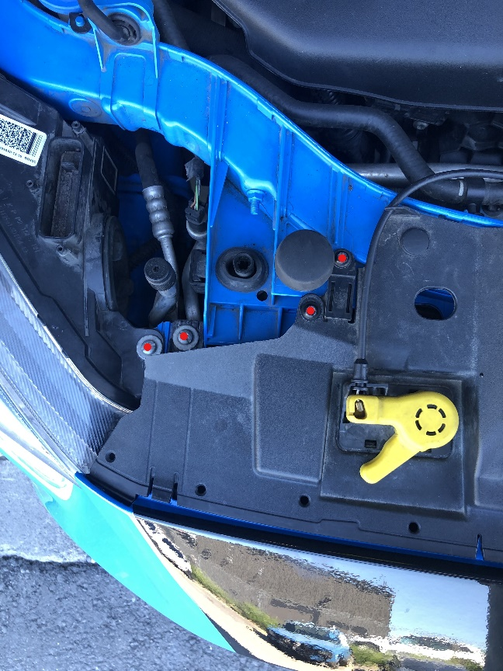
Remove/disconnect all highlighted hardware, both sides.

Step 2: Remove Air Dams
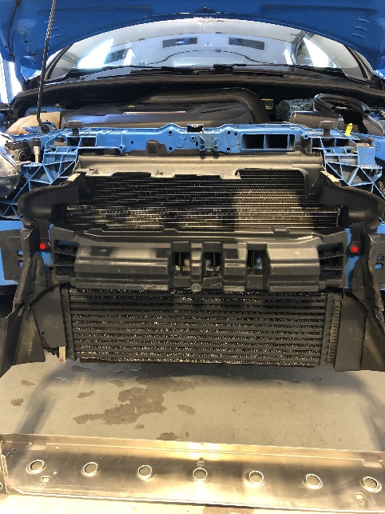
Step 3: Drill Factory Mounting Location
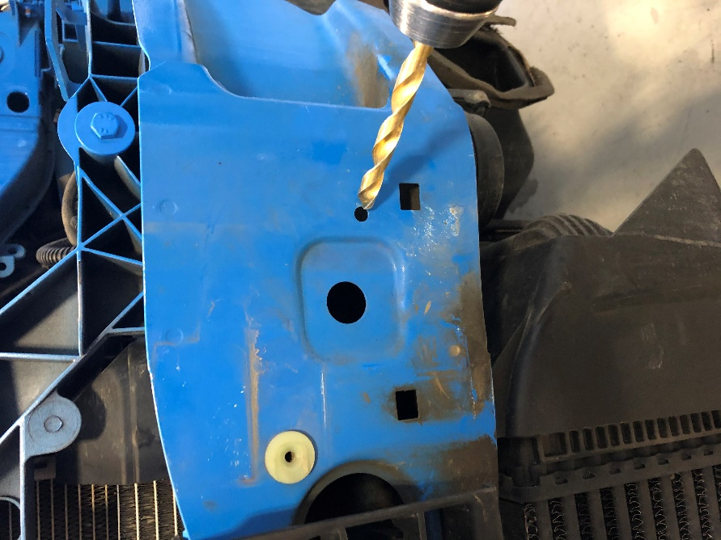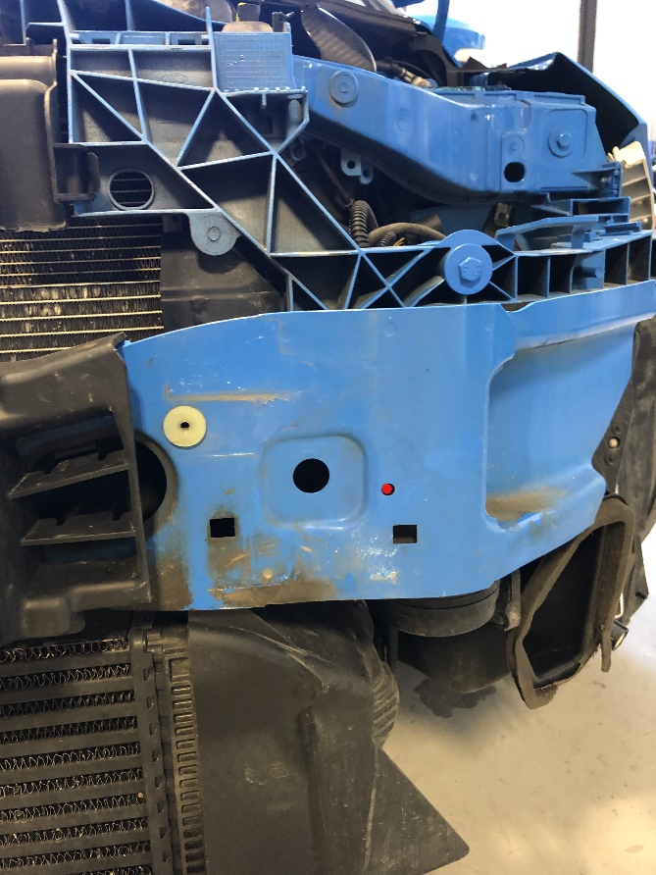
Both sides with 11/32nd drill bit.
Step 4: Install Center Bracket – Check Clearance
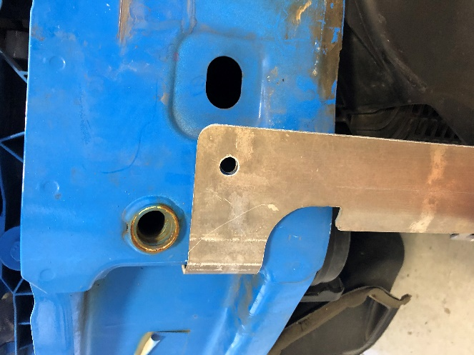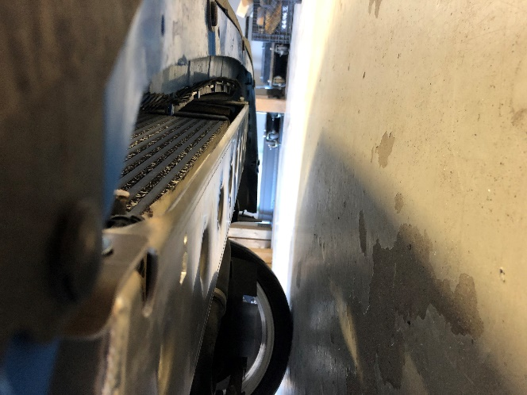
May require remounting bumper to ensure splitter is set at correct height. Use height adjustment bolts on center bracket as necessary.
Step 5: Mark Two Front Hole Locations on Splitter
Once center bracket is mounted at correct height mark front two-hole locations on Infamous Aero Front Splitter.
Step 6: Remove Center Backet & Fully Mount Splitter to Center Bracket
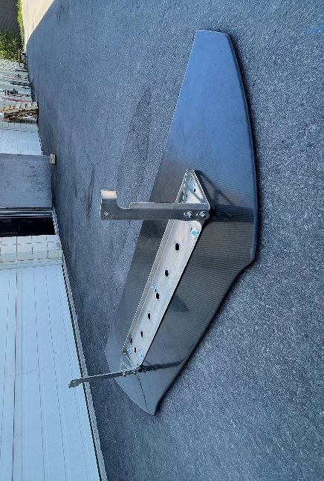
Mark and drill remaining three holes on center bracket. *Drill down if splitter includes carbon overlay option.
Step 7: Re-Install Center Bracket & Side Brackets
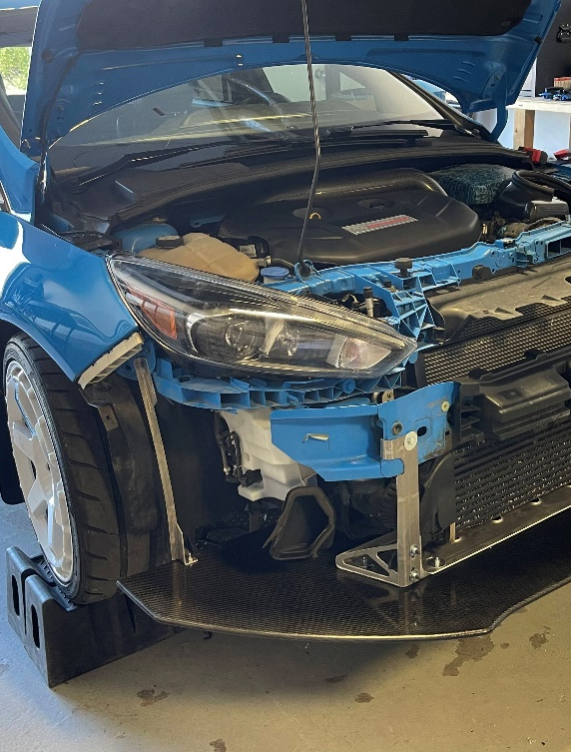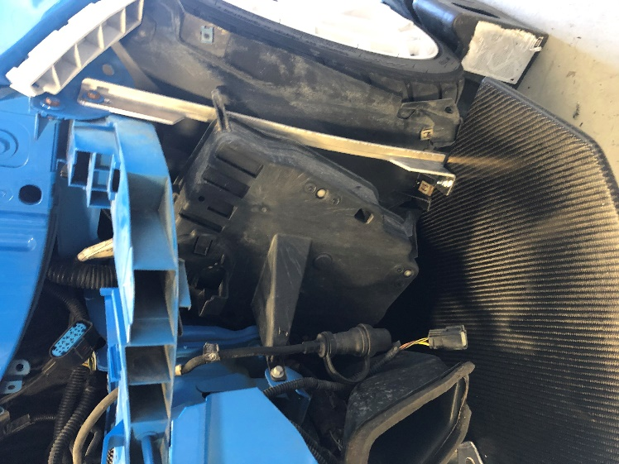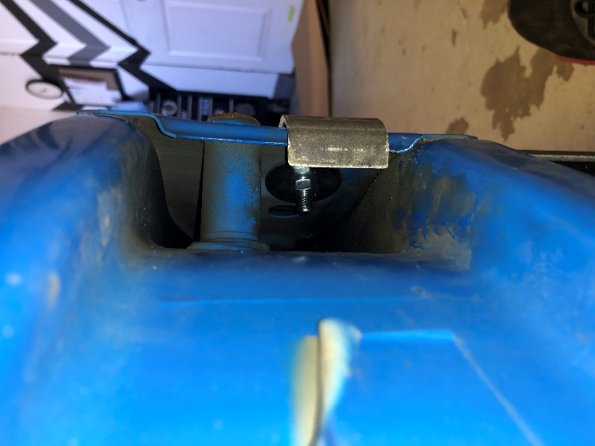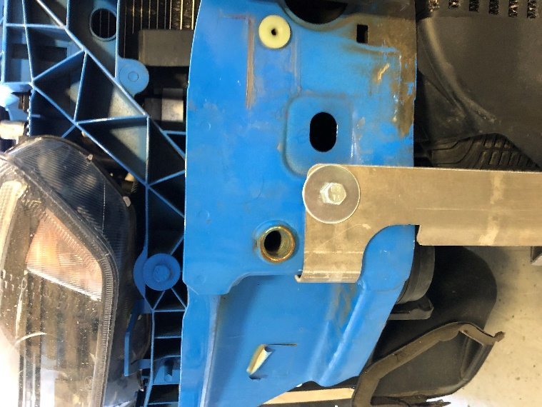
Side brackets can be installed once center bracket is fully mounted and in its final position using OEM bolt and bolt location. Ensure provided fender washers are used on front and back of center bracket mounting locations.

Step 8: Re-Install Air Dams
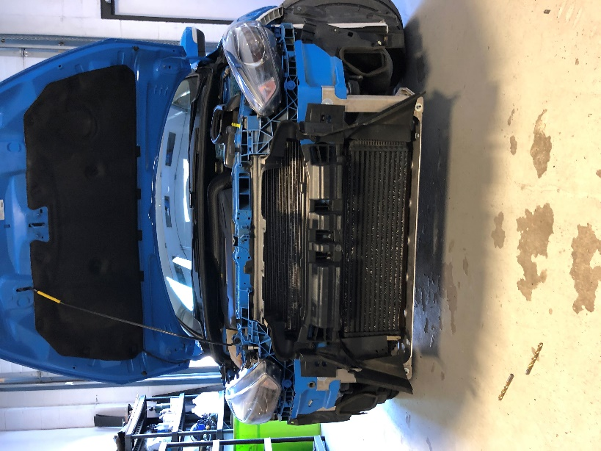
INFAMOUS AERO Bracket System does not require deleting any factory panels or air dams.
Step 9: Re-Install Front Bumper
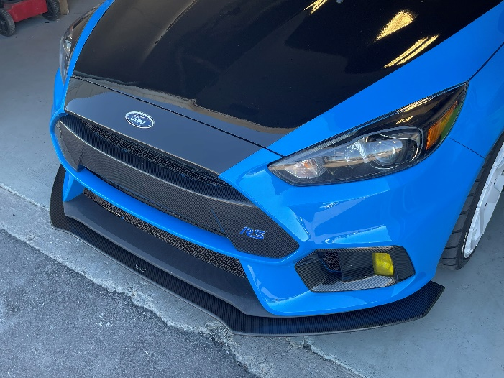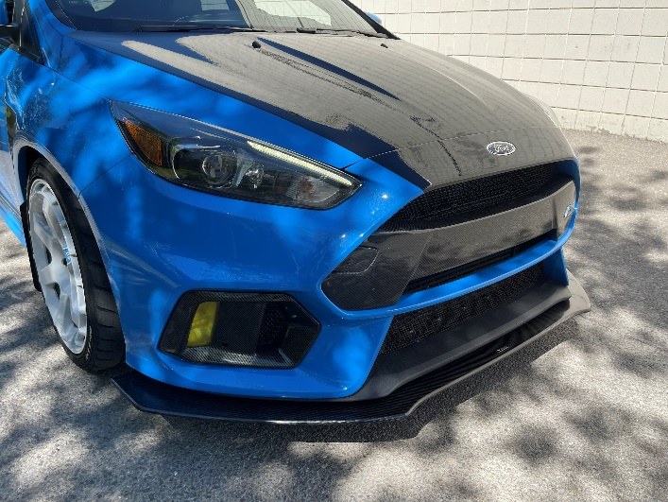
Thank-you for your support and Welcome to the INFAMOUS AERO TEAM.
If you have any further questions do not hesitate to contact info@infamousaero.com.

